Read Me:

Steps:

1. Install node js.
2. Within calendar-application folder execute command:

Create-react-app calendar-application

1. Cd calendar-application
2. Execute “npm start” command to execute react js application. React js app will by default run on 3000 port in browser.
3. To set up server create server.js file

i.In outer calendar-application folder.

ii.create server folder

iii.create server.js file where u will add functions for get and post api

Follow steps from <https://www.codementor.io/kakarganpat/how-to-setup-react-and-node-js-in-a-project-koxwqbssl>

Link

It is followed by server/bin/www file edit where I edited in www file port to 3001.

Then edit package.json file for outer folder to run both server node and react simultaneously.

1. In outer calendar-application folder run npm start.
2. Output: client will run on port 3000(default), we can change port in package.json file placed in client folder by setting proxy. Server will run on 3001 port.
3. The user can select date and save by clicking on submit button. Test.txt file created in server folder which will save date.
4. Testing, Used enzyme by following below link:

<https://airbnb.io/enzyme/>

Output:

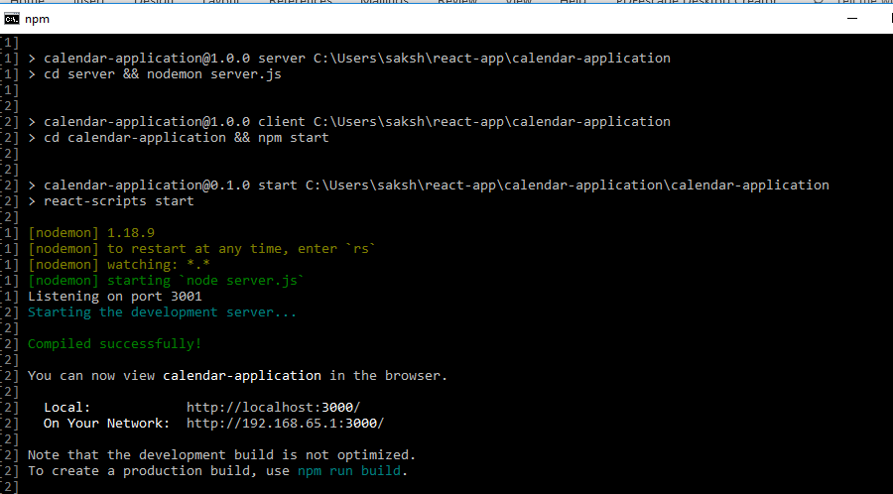

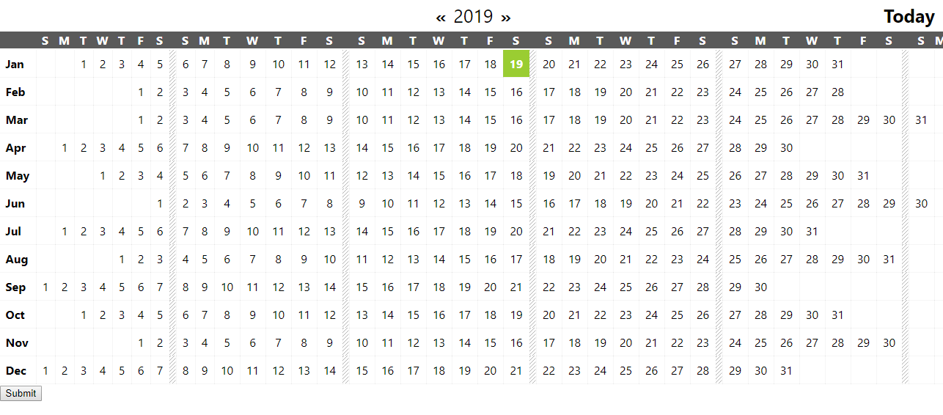

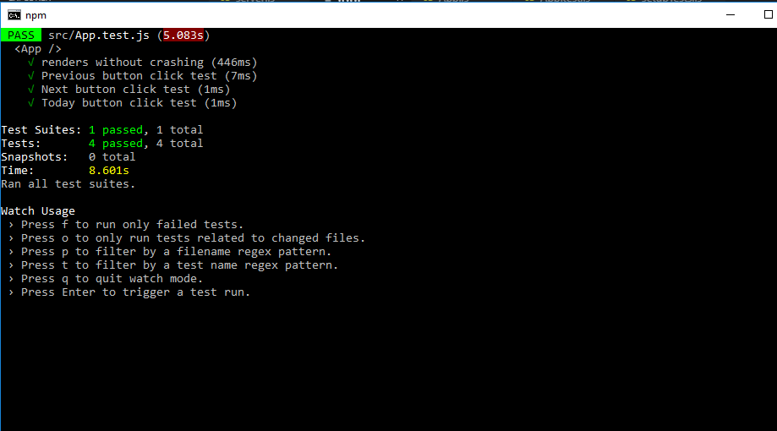

References:

React js link:

<https://www.youtube.com/watch?v=Ke90Tje7VS0>

Node and React js set up:

<https://www.codementor.io/kakarganpat/how-to-setup-react-and-node-js-in-a-project-koxwqbssl>

API consumption:

<https://flaviocopes.com/fetch-api/>

And many more

Testing:

<https://airbnb.io/enzyme/>